**Visited RDA(Rural Development Academy),Bogra**

RDA has been a leading institute for training, research, action research, and field implementation for some time now. RDA has developed more technical and social skills and expertise in conducting rural development experiments during its previous operations. In this context, RDA wants to pursue the process of further operations tobecome a Centre of Excellence for Rural Development.

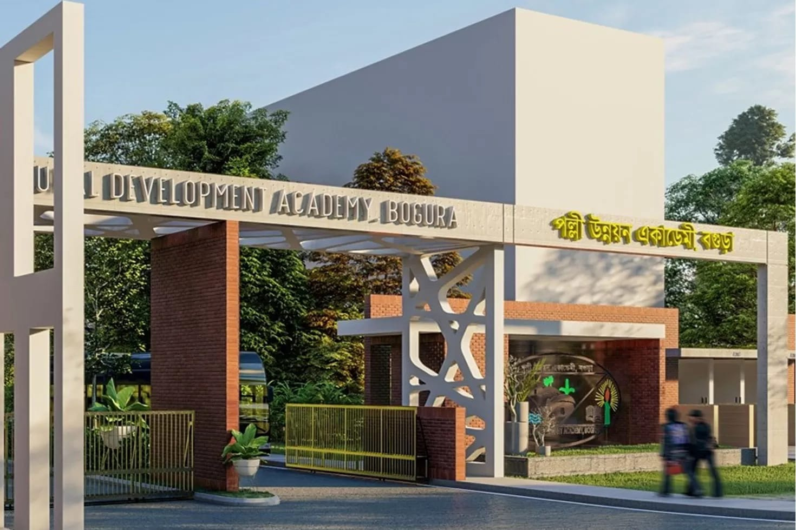

RDA(Rural Development Academy),Bogra

**Introduction**

**Rural Development Academy (RDA), Bogra**

Bangladesh Government established the Rural Development Academy (RDA),After the liberation war.Bogura allocating Tk. 2.00 crore in the 1st five year plan of the newly independent Bangladesh. As a result, RDA is provides as one of the prime development land mark made by the Father of the Nation.Rural Development Academy (RDA), Bogura was established on 19 June 1974 as a specialized national institution engaged in rural development related training, research and action research. It also provides advisory services and offers post graduate diploma. Since last four decades RDA has gained a strong reputation in rural development field and has provided an active link between its academic ventures and the application of research findings at a practical field. This has been viewed by the concerned experts and policy makers and reflected by achieving several national and international recognitions.

**POLICY PROFILE**

The Board of Governors (BOG) is the apex policy body of RDA represented from the policy makers, tops- level administrators, academicians and development professionals of the country. The BOG determines policies, approves annual overall activities and endorses functional agenda of RDA.

**BOARD OF GOVERNORS**

Chairperson

Hon'ble Minister/Hon'ble State Minister

Ministry of Local Government, Rural Development and Cooperatives

Government Nominated Members

Four (4) members nominated by the Government of Bangladesh. Members

1. Secretary, Ministry of Public Administration

2. Secretary, Ministry of Finance

3. Secretary, Ministry of Agriculture

4. Secretary, Ministry of Local Government

5. Secretary, RDCD, Ministry of LGRD & C

6. Member, Planning Commission

7. Rector, BPATC

8. Director General, BRDB

9. Director General, BARD

10. Commissioner, Rajshahi Division

11. Registrar & DG, Department of Co-operatives

12. Director, IBS, Rajshahi University

13. Vice Chancellor, BAU, Mymensingh

14. Director General, NILG

Member Secretary

Director General, RDA, Bogura.

MINISTRY

Rural Development & Cooperative Division, Ministry of LGRD & Cooperatives

**MISSION**

**RDA is engaged to deliver sustainable rural development through innovation and practices. The academy contributes to:**

improveand disseminate models, technologies and approaches to address the rural developmentchallenges;enhance capacity of rural development experts, practitioners, and change agents;promote climate change resilient development: reduce poverty, andimprove gender parity and women's empowerment.

**VISION**

The vision of the Rural Development Academy (RDA), typically, shows on promoting sustainable rural development through capacity building, innovation, and the implementation of various development programs. The general goal is to uplift rural communities by improving their socioeconomic conditions, with an emphasis on poverty alleviation, agricultural development, infrastructure, and human resource development.

If you're referring to a specific document or version of the RDA's vision, feel free to share more details, and I can provide a more targeted response.